DSC640-T301 - 3.3 Project Task 3: Blog Post

Soukhna Wade

Bellevue University

**DSC640 Bellevue University 07/12/2020**

**Soukhna Wade**

**3.3 Project Task 3: Blog Post**

[**https://souwade2.blogspot.com/2020/07/airline-safety-1985-2014.html**](https://souwade2.blogspot.com/2020/07/airline-safety-1985-2014.html)

[](https://www.blogger.com/)

*by  Soukhna Wade*

[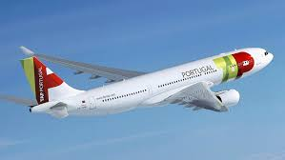](https://www.blogger.com/)

The aviation industry is the business sector dedicated to manufacturing and operating all types of aircraft. Air traffic controllers, when they are awake, are concerned with aviation safety. This page is to evaluate airline safety using the data for 56 airlines that were in the global top 100 as

of December 2012 and which have operated continuously since Jan. 1, 1985. Airlines are sorted based on the rate of fatalities. The data is located under  [Airline Safety](https://www.blogger.com/), GitHub. 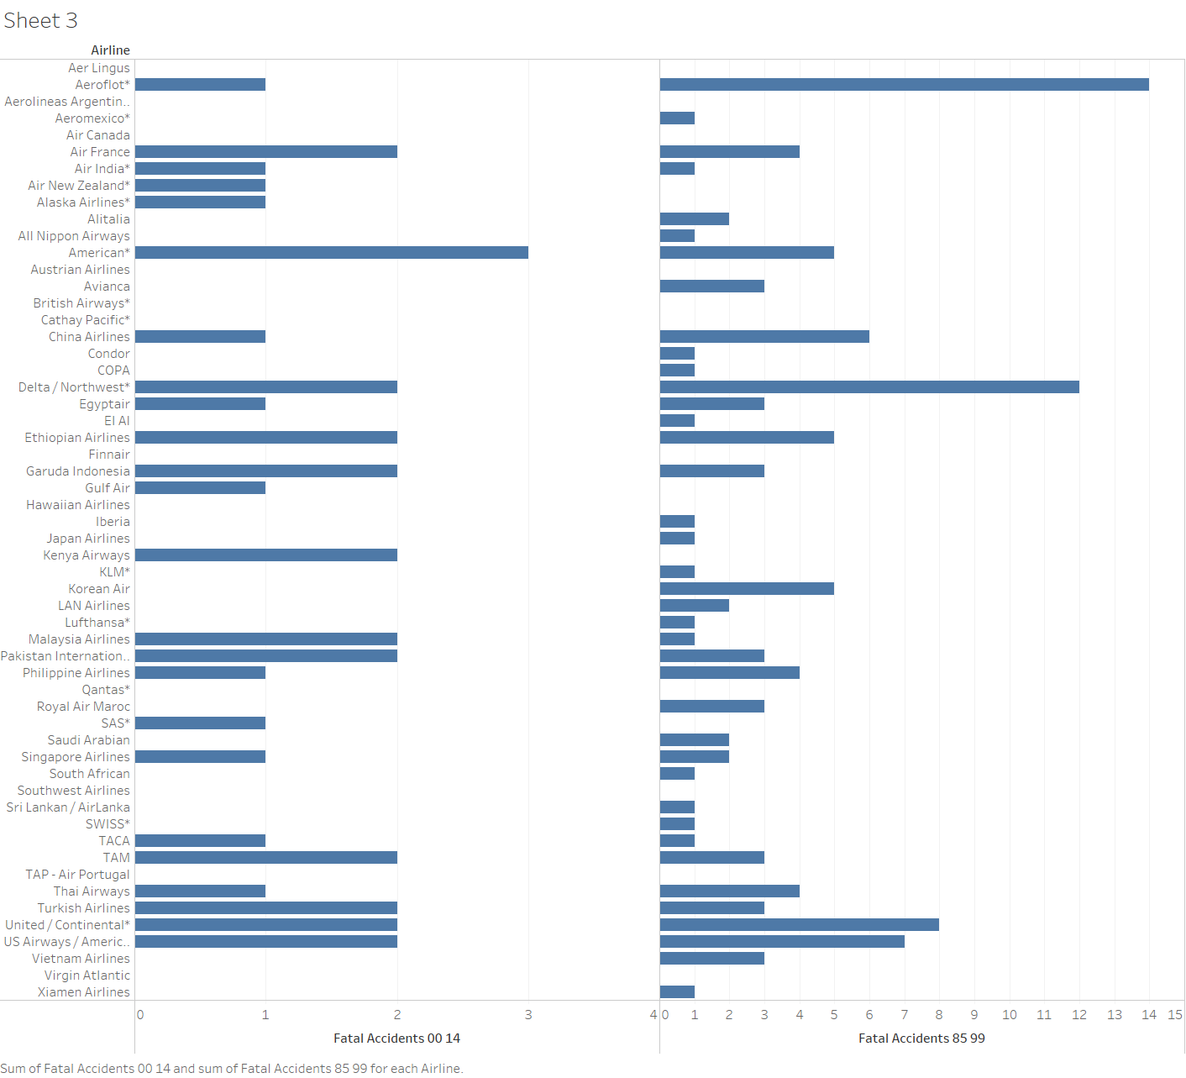China Airlines has a higher fatality number. It had 535 fatalities between 1985-1999 and 225 fatalities between 2000-2014. Although China Airlines' number of fatalities is not very consistent from 1985 to 2014, it has the highest number of fatalities than any other Airline on the list.  Airlines' fatality number can be explained by many factors such as weather, technical problems, security issues, lack of training. For instance, China Airlines was also criticized for insufficient training. The disappearance of Flight MH370 of Malaysian Airlines on 8 March 2014 seems to be related to the weather issues.

The airlines in the list with high total incident numbers also have higher total fatal accident numbers between 1985-1999. For example, Aeroflot had 88 total incidents and 15 fatal accidents between 1985-2014 that might be caused hard landing of The safest airline is TAP-Air Portugal,  TAP has one of the best safety records of any airline in the list with only one incidence between 1985 to 2014;  follows by Virgin Atlantic, Hawaiian Airlines, Finnair.  The safest airline is TAP-Air Portugal.   TAP has one of the best safety records of any airline in the list with zero incidences and zeroes fatal accident between 1985 to 2014; follows by Virgin Atlantic, Hawaiian Airlines, Finnair.  This Portuguese flag carrier TAP has dropped three places, from fourth to the seventh position, in the world airline safety ranking.  However, the Portuguese airline is still among the 10 safest airlines in the world, according to a report from the Jet Airliner Crash Data Evaluation Center (JACDEC).

 TAP Air Portugal is the flag carrier airline of Portugal. It is headquartered at Lisbon Airport which also serves as its hub. TAP (Transportes Aéreos Portugueses) has been a member of the Star Alliance since 2005 and operates on average 2,500 flights a week to 90 destinations in 34 countries worldwide. The company has a fleet of 100 airplanes, all of which manufactured by Airbus except for 22 made by Embraer and ATR, operating on behalf of the regional airline TAP Express.

 Portuguese flag carrier TAP has dropped three places, from fourth to the seventh position, in the world airline safety ranking. However, the Portuguese airline is still among the 10 safest airlines in the world, according to a report from Jet Airliner Crash Data Evaluation Center.

Air New Zealand ranked second, and Cathay Pacific from Hong Kong was in the third position. British airways listed 10th in the ranking, moving up 10 places on 2011’s report by JACDEC.

TAP was pushed down the list by two airline companies in the United Arab Emirates, Emirates and Etihad Airways, and one from Taiwan, Eva Air.

As you can see TAP continues to be one of the few airline companies that have not recorded a plane crash in over 30 years, according to the JACDEC report, the reason why it dropped three places in the ranking hat to do with the airline fleet age, which is above the average of other fleets. TAP has plans to renew.

**References**

https://www.portugalresident.com/tap-among-10-safest-airlines-in-the-world/

<https://www.worldfinance.com/strategy/market-conditions-threaten-malaysia-airlines-survival>

<https://en.wikipedia.org/wiki/TAP_Air_Portugal>